1. Row level security

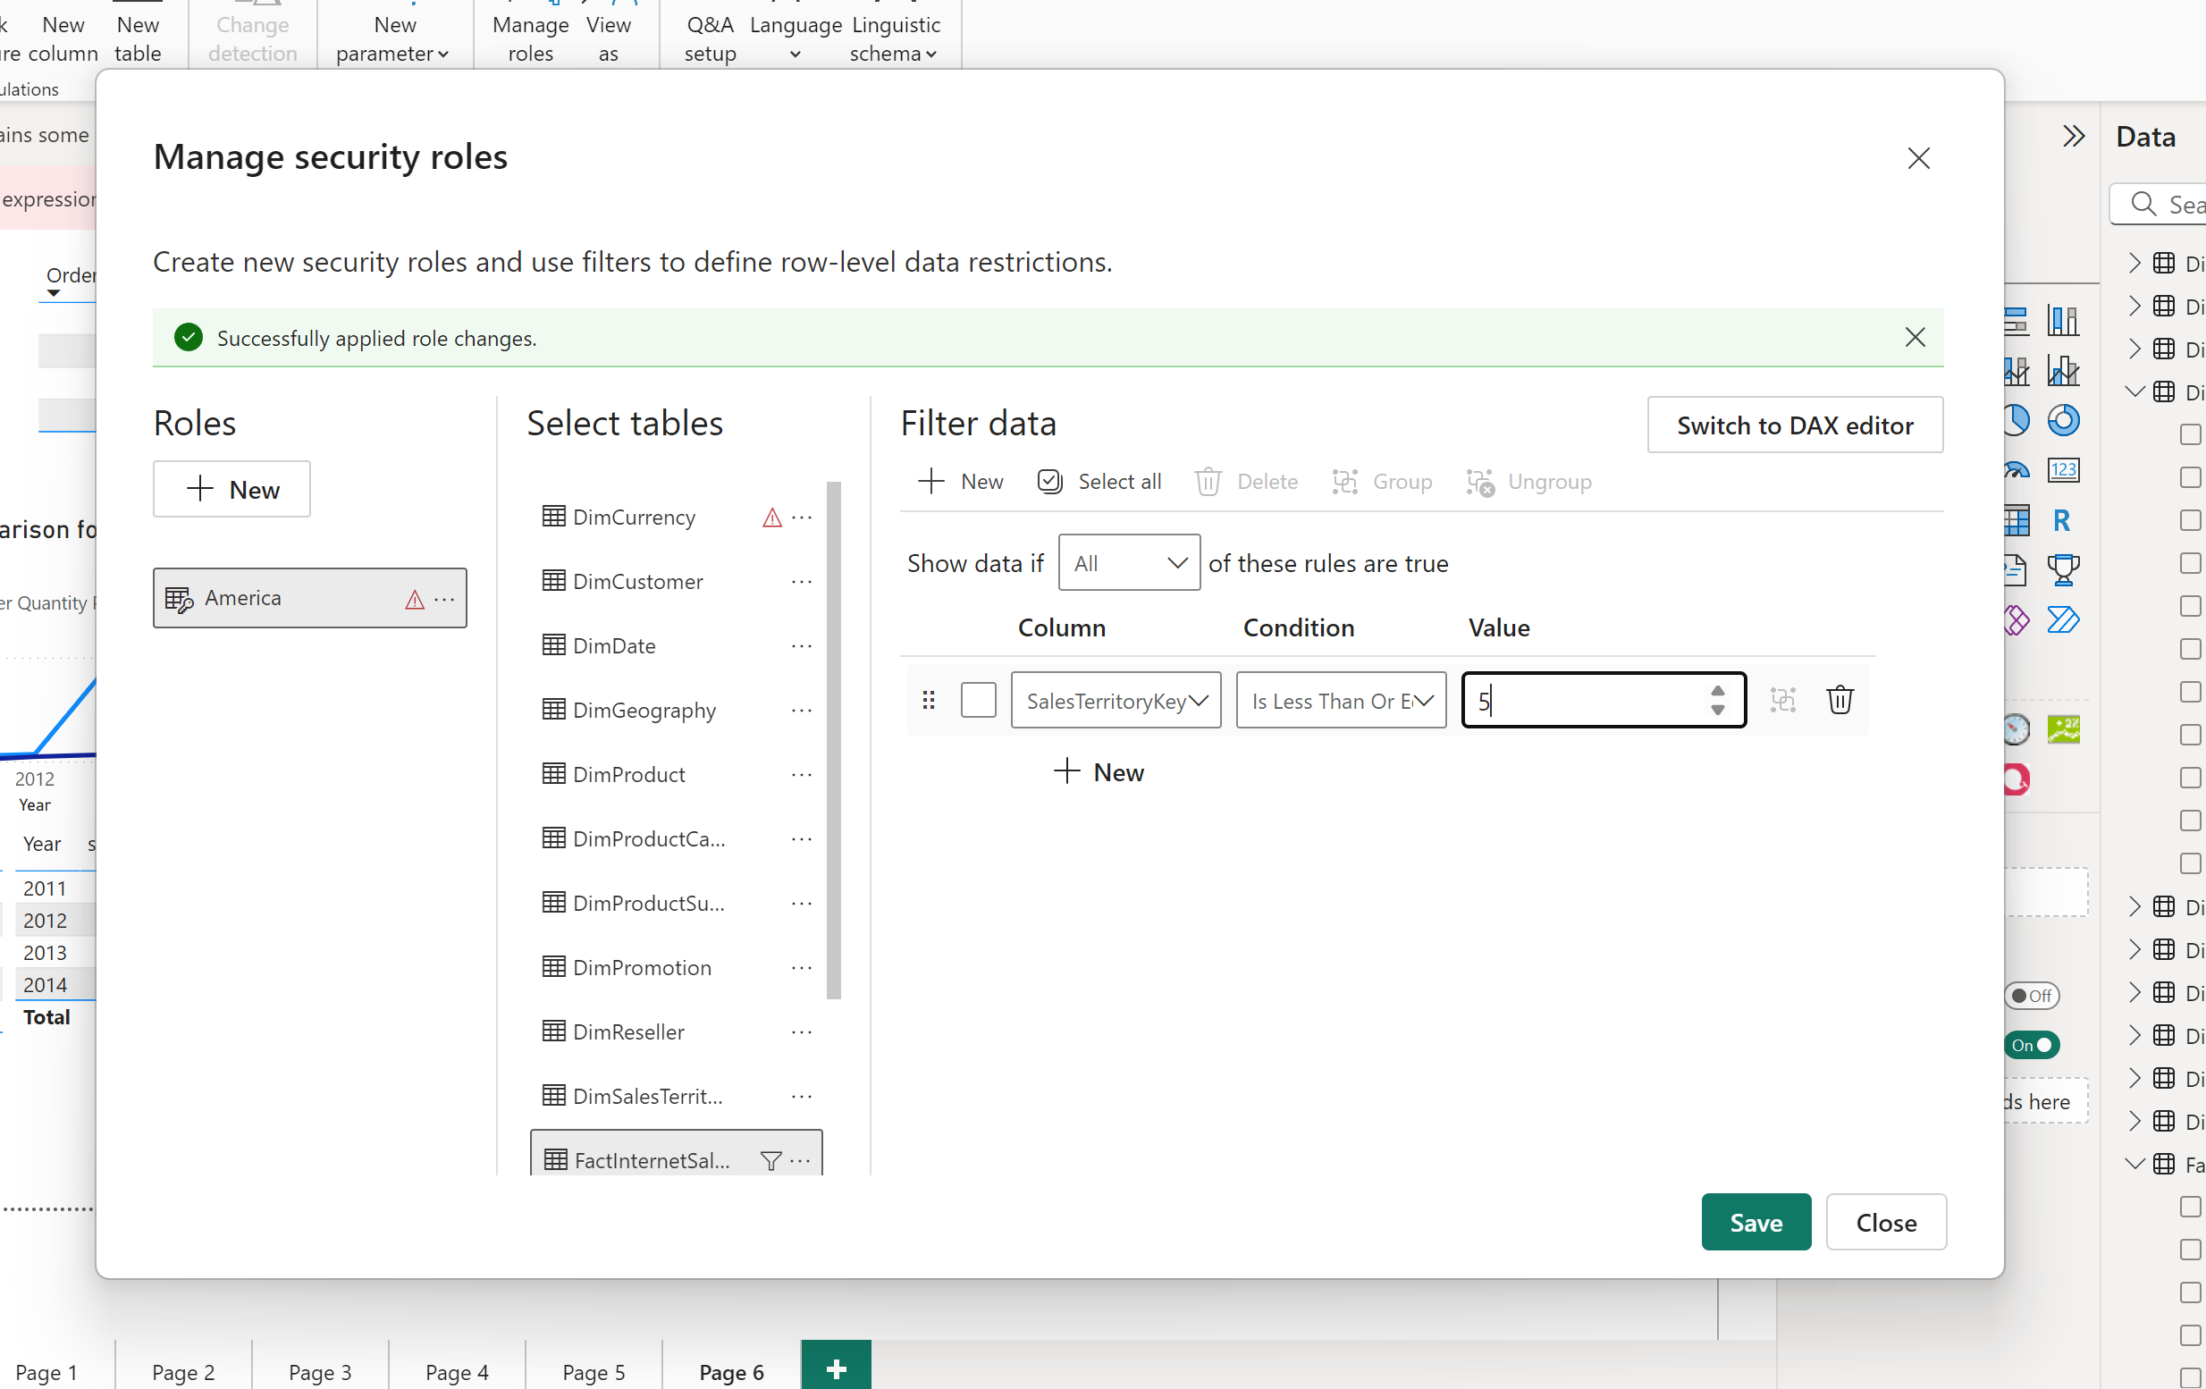

Adding row level security on fact internet sales to get America specific role, by only selecting Americas specific regions which are from one to five.

I added myself in row level secutriy in service

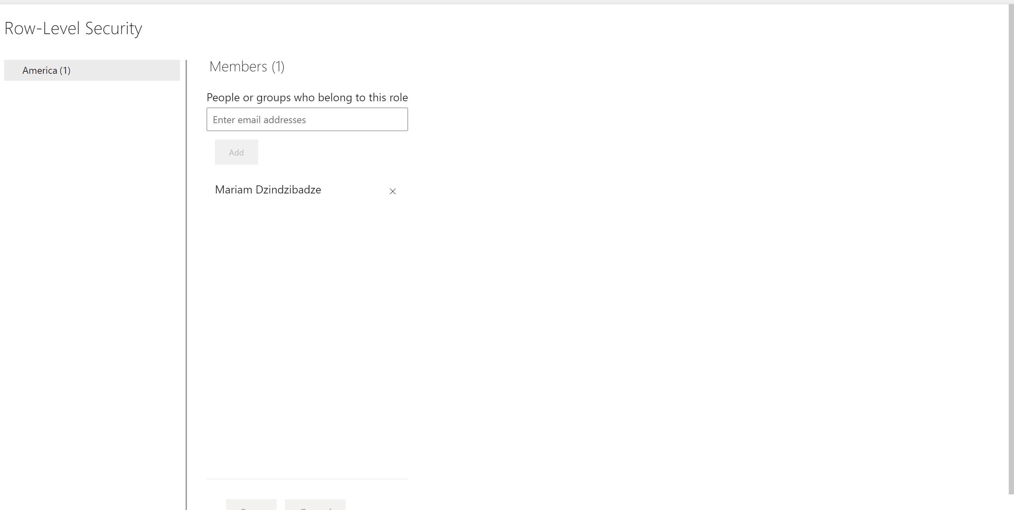

1. Created bookmarks “Bar chart” and “Map visual” on the bar chart and on the map  
   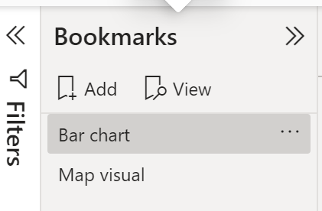   
   Then created buttons next to both that lead to opposite bookmarks  
   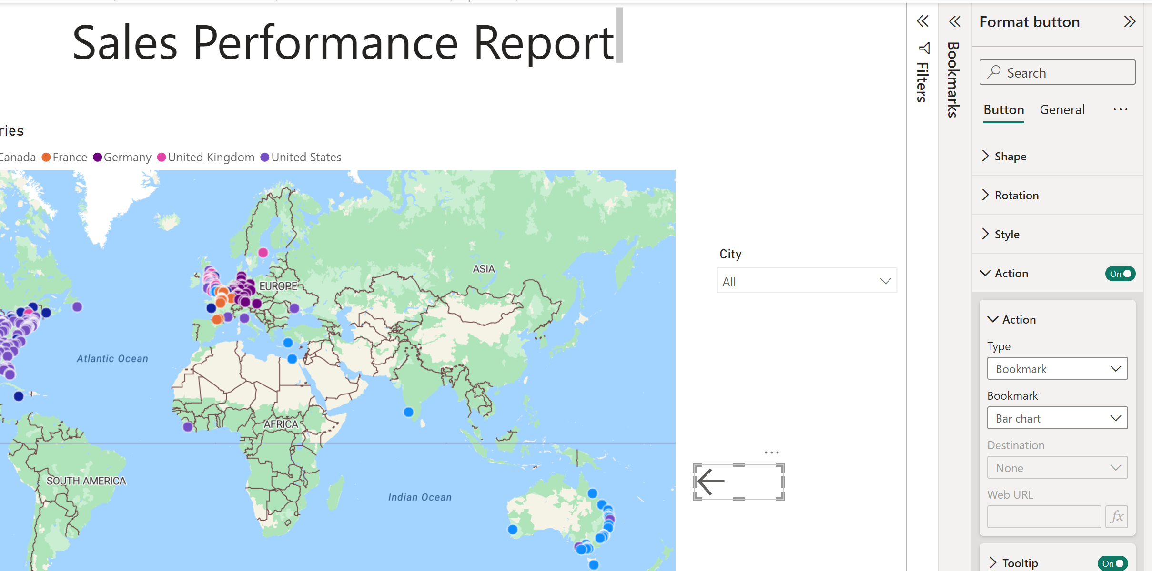
2. TODO
3. 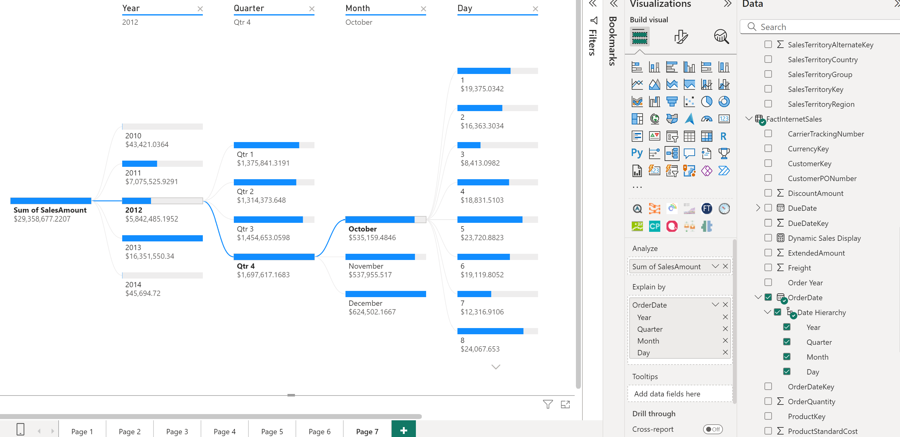 Drilled down sales amount in FactInternetSales by year quarter month day
4. 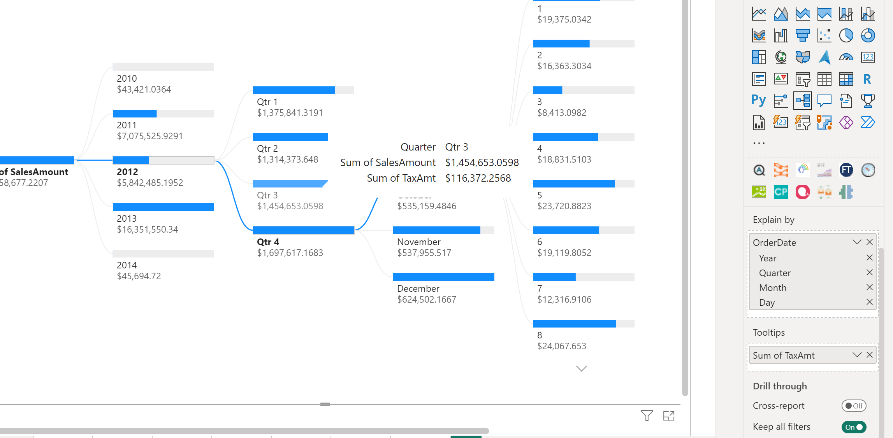 Showing total tax amount in tooltip